* I have not used image upload facility. Project uses random images
* Full CRUD operation is available

**Procedure to run**

1. **Inside “backend” folder, run index.js file**
2. **Then inside “frontend” folder, type : npm run dev**

**Opening screen**

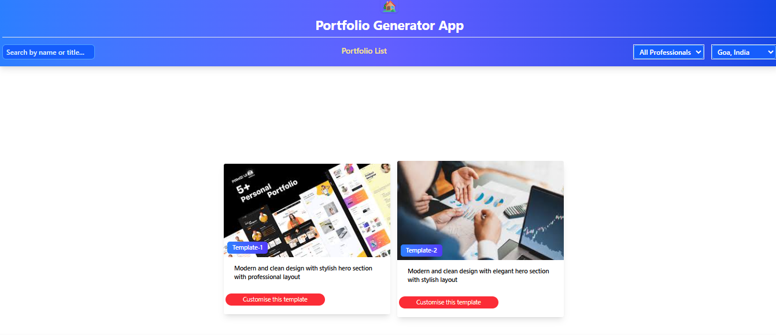

**Profile lists**

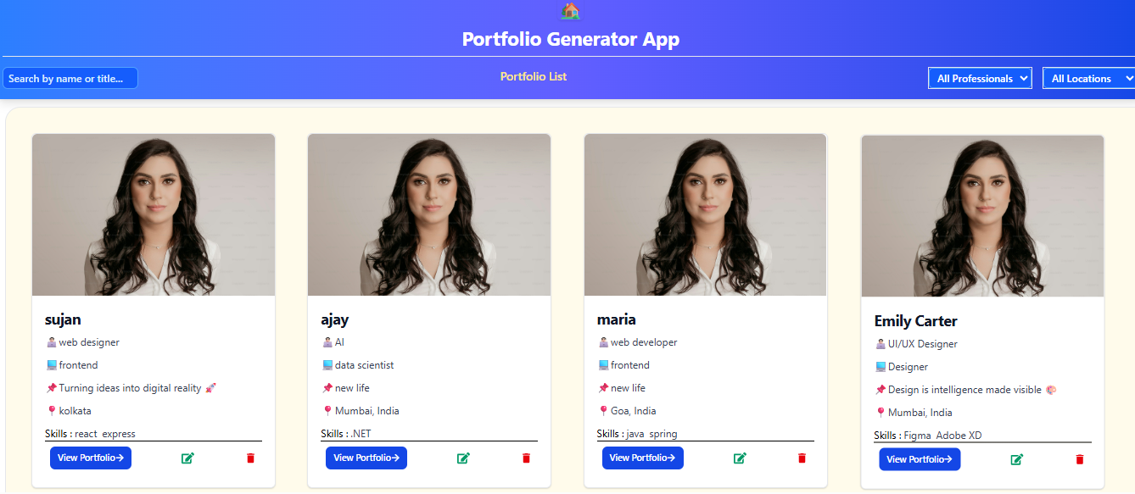

**Portfolio**

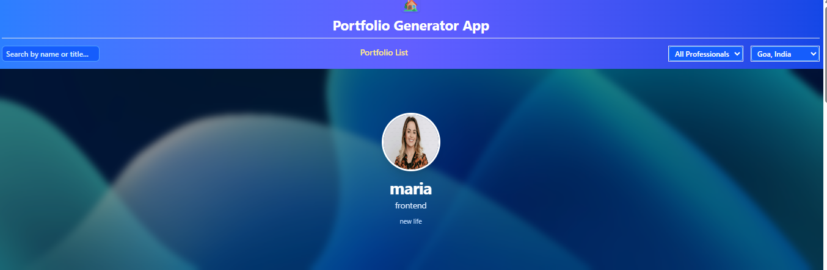

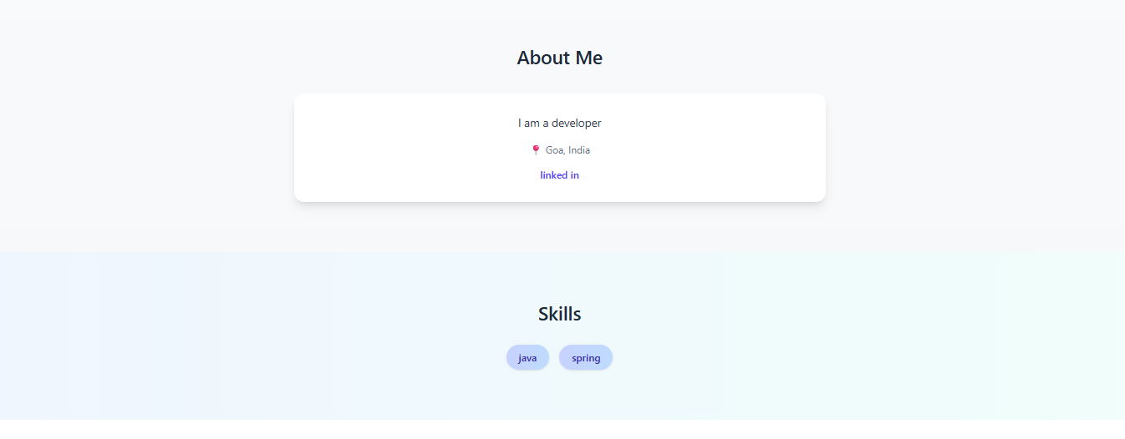

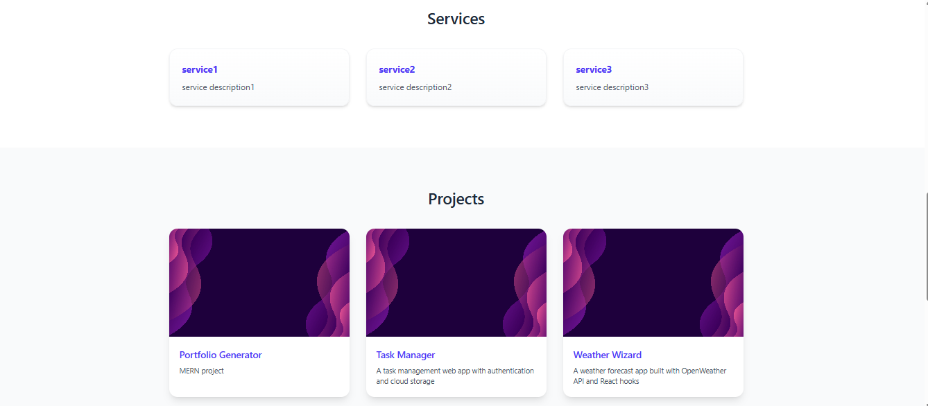



**Searching on role**

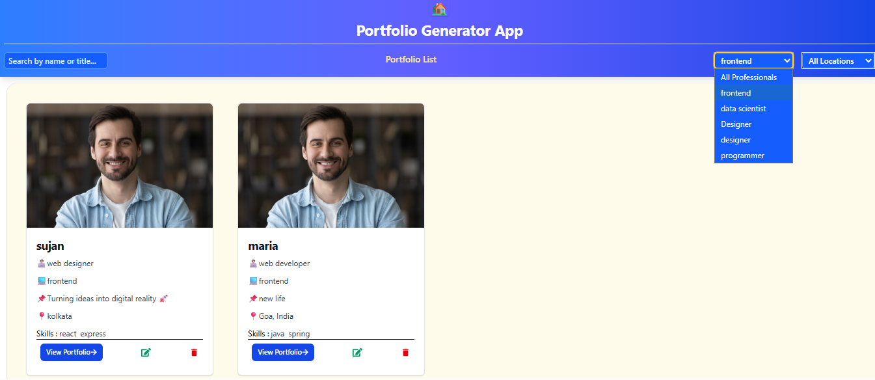

**Searching on location**

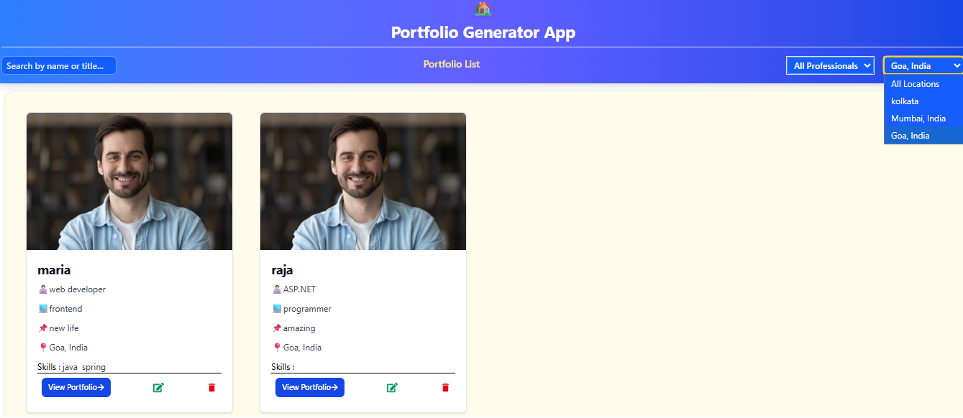

**Edit screen**

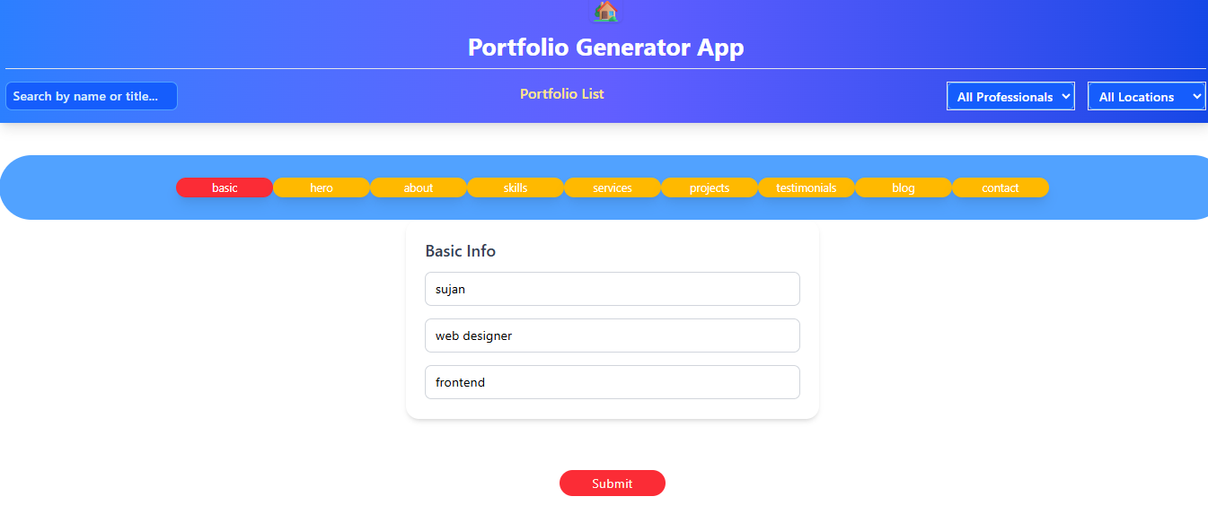

**Section tabs to create portfolio after clicking “customise template” button**

